

## Department of Computer Science & Engineering

Rajshahi University of Engineering & Technology

# LAB REPORT

## Topic: Introduction to Linux and Its Basic Commands.

## Course No: CSE 3202

## Course Name: Sessional Based on Operating Systems

Submitted By

Saifur Rahman

Roll No: 1703018

Section: A

CSE, RUET

Submitted To

Mohiuddin Ahmed

Lecturer

CSE, RUET

Date of Submission: 21st Mar 2022

Date of Lab: 7th Mar 2022

# INDEX

Topic No: 1 1

Topic Name: Introduction to Linux and Its Basic Commands. 1

Objectives 1

Theory 1

Linux 1

Advantages of Linux 1

Distributors of Linux 1

Shell 1

Types of Shell 1

Commands 2

cd ‘directory_name‘ 2

cd /mnt/’directory_name’ 2

pwd 2

ls -al 3

touch ‘file_name.txt’ 3

nano ‘file_name.txt’ 4

cat ‘file_name.txt’ 4

rm ‘file_name.txt’ 5

mkdir ‘folder_name’ 5

cd .. 6

chmod u = rwx ‘folder_name’ 6

Shell Coding 7

Header 7

File Extension 7

Command to run code 7

echo ‘string’ 7

CODE: 7

Discussion 8

#### Topic No: 1

#### Topic Name: Introduction to Linux and Its Basic Commands.

#### Objectives

* To learn about Linux operating system.
* To learn about windows subsystem for Linux.
* To learn basic Linux commands.
* To learn shell coding.

#### Theory

##### Linux

Linux is an open-source operating system modelled on Unix. It began as a personal project by Finnish student Linus Torvalds. In 1991, while studying computer science at University of Helsinki, Linus Torvalds began a project that later became the Linux kernel. He wrote the program specifically for the hardware he was using and independent of an operating system because he wanted to use the functions of his new PC with an 80386 processor. Development was done on MINIX using the GNU C Compiler.

##### Advantages of Linux

* Open source
* High security and stability
* Ease of maintenance
* Runs on any hardware
* Free
* Ease of use
* Flexibility in customization

##### Distributors of Linux

* Debian
* Gentoo
* Ubuntu
* Linux Mint
* Red Hat Enterprise Linux
* CentOS
* Fedora
* Kali Linux

##### Shell

Shell is an interface between the user and the kernel. It provides a platform to interact with the kernel. Here we can run our commands, programs, and shell scripts.

##### Types of Shell

* Bourne Shell (sh)
* Bourne Again Shell (bash)
* C Shell (csh)
* Z Shell (zsh)
* Korn Shell (ksh)
* POSIX shell (sh)

#### Commands

##### cd ‘directory_name‘

changes directory to ’directory_name’

##### cd /mnt/’directory_name’

changes directory to ’directory_name’ [on windows subsystem for Linux]

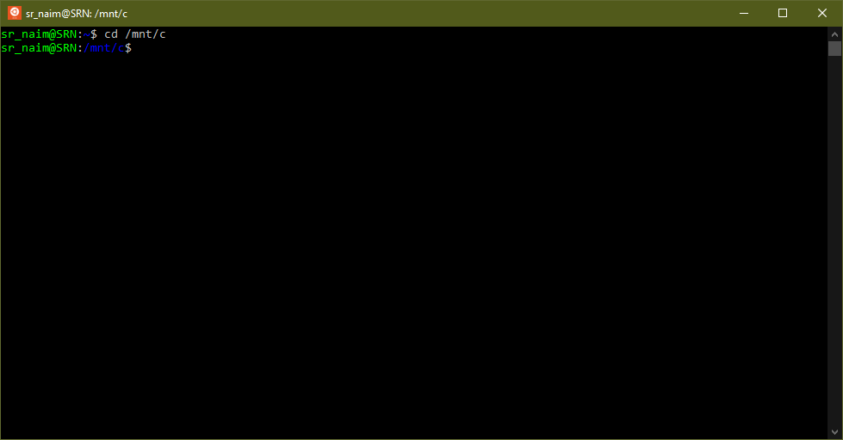

##### pwd

Shows present working directory

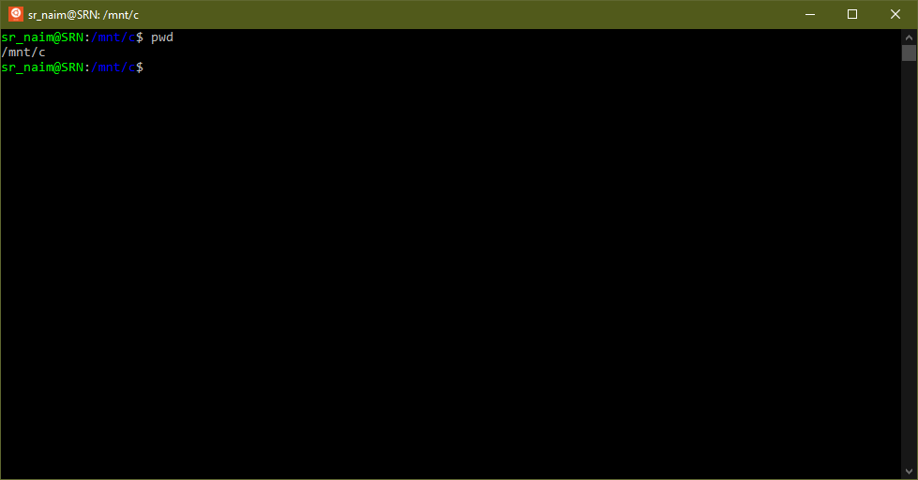

##### ls -al

List of all files and directories

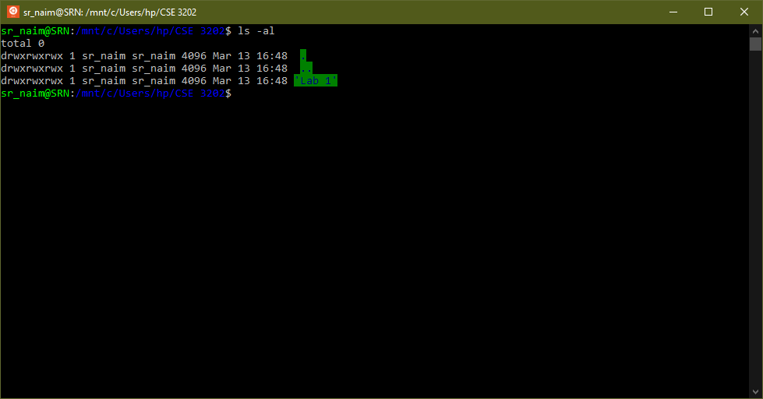

##### touch ‘file_name.txt’

creates a file named ‘file_name.txt’ in that directory

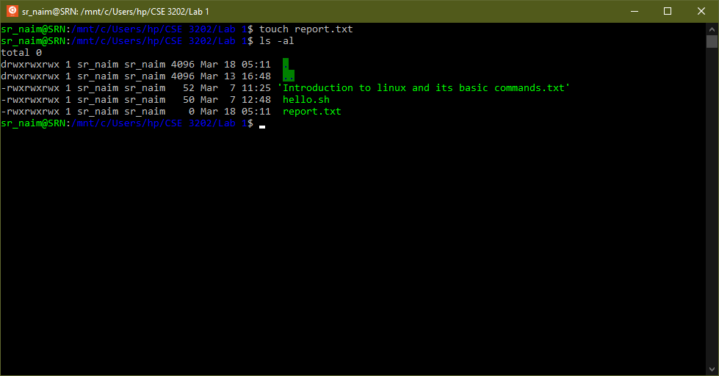

##### nano ‘file_name.txt’

Opens GNU nano editor for editing ‘file_name.txt’

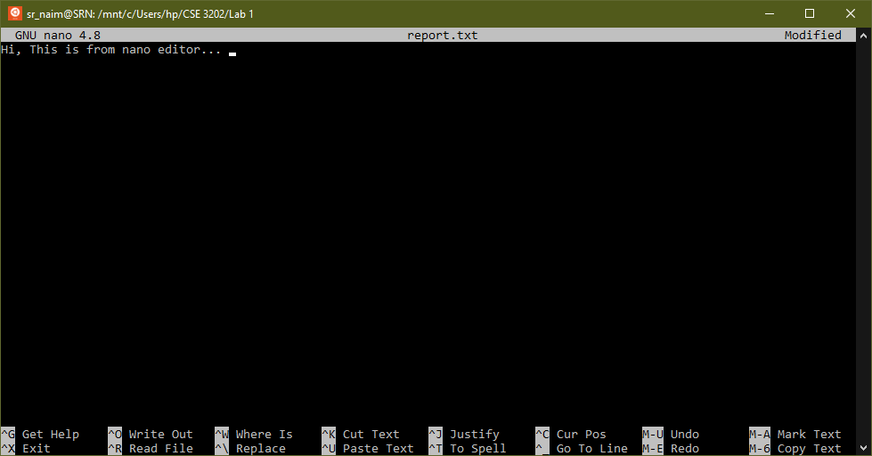

##### cat ‘file_name.txt’

shows the text on kernel

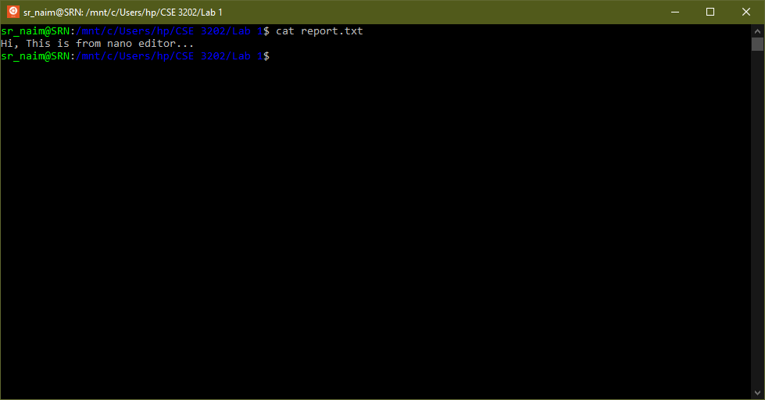

##### rm ‘file_name.txt’

deletes file from directory

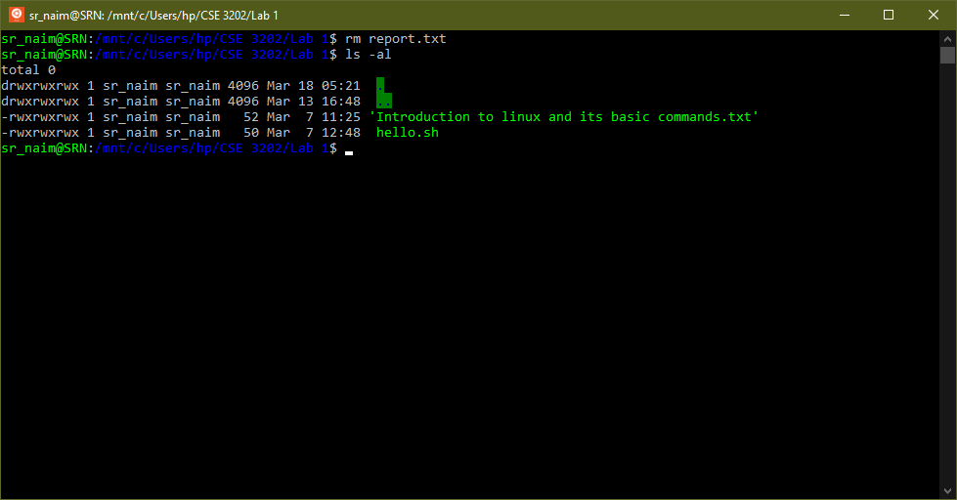

##### mkdir ‘folder_name’

creates a folder

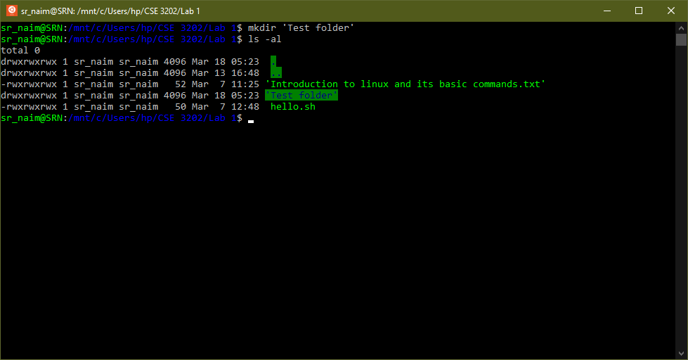

##### cd ..

Returns to parent folder

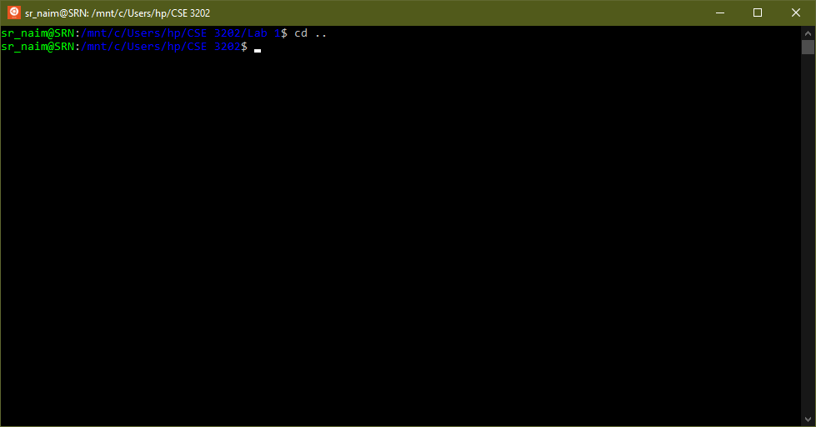

##### chmod u = rwx ‘folder_name’

Changes permissions of file or directories

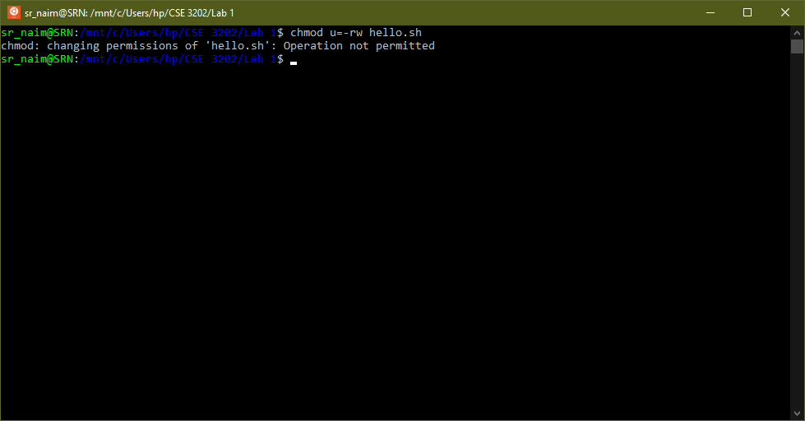

#### Shell Coding

##### Header

#! /bin/bash

##### File Extension

.sh

##### Command to run code

./’file_name’

##### echo ‘string’

prints ‘string’

#### CODE:

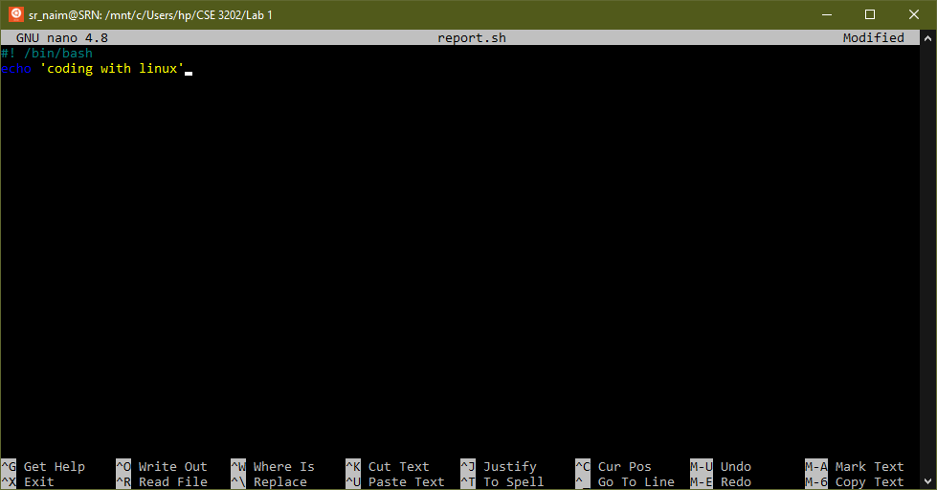

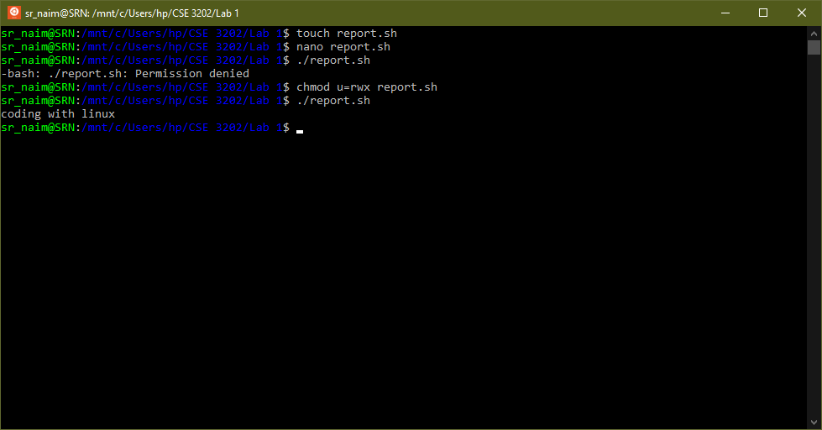

#### Discussion

While running a .sh file it shows ‘Permission denied’. Because the user does not have the permission to execute the file. So, we needed to use ‘chmod’ command to make that file executable.

The ‘chmod’ command shows an error ‘Operation not permitted’ because user is not the owner of /root folder. So, the change of permission can only be done by the root user.

Generally, the ‘chmod’ command does not work in WSL. Because ‘chmod’ does not change file permissions of files stored on NTFS or fat32 file systems. So, files are needed to be copied on WSL file system. This is done by two commands:

sudo umount /mnt/c

sudo mount -t drvfs C: /mnt/c -o metadata